Soil Health (soil microbial component) of Littlefield/SPADE farms (2014-2018)
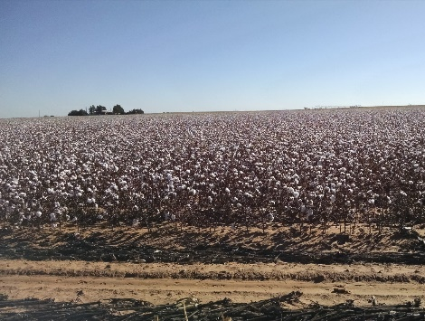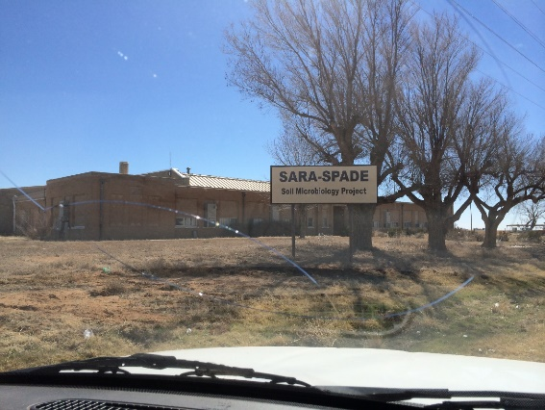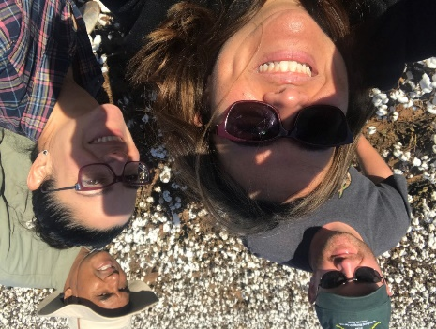

AGENDA

11-11:15am- Welcome by Verónica Acosta-Martínez (soil microbiologist) and Bill Jones

11:15-11:45am – Discussion of trends found on microbial component as indicator of soil health
by Lumarie Pérez-Guzmán and Verónica Acosta-Martínez
- Climate variability in the Texas High Plains region (2014-2018)
- Effects of Management practices in soil health

11:45-12:00pm – Discussion of rain water infiltration studies by Tim Goebel

12-1pm – Lunch and informal discussion/more questions-networking

NOTE:
Please use this sheet for any questions or comments, and please provide your name, phone or email.

